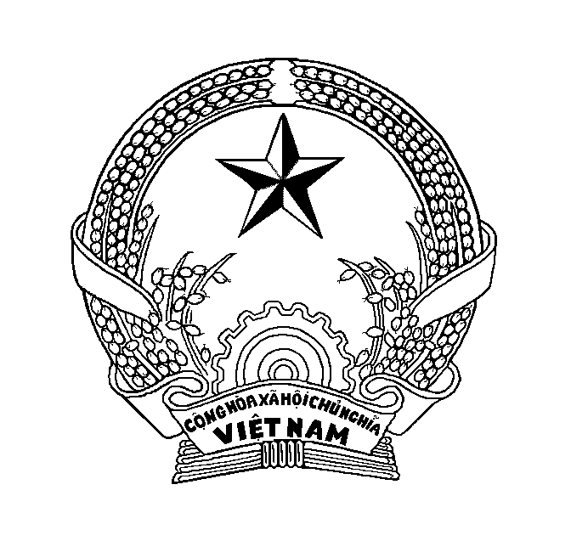
MINISTRY OF AGRICULTURE AND RURAL DEVELOPMENT - SOCIALIST REPUBLIC OF VIET NAM
NATIONAL AGRO-FORESTRY-FISHERIES QUALITY ASSURANCE DEPARTMENT
BRANCH 6
Add: 386^{C} CACH MANG THANG 8 ST., BUI HUU NGHIA WARD, BINH THUY DIST., CAN THO CITY, VIETNAM
Tel: 84-292-3883257; Fax: 84-292-3884697; E-mail: tonghop.nafi6@mard.gov.vn
HEALTH CERTIFICATE FOR PRAWNS AND PRAWN MEAT FOR HUMAN CONSUMPTION
Certificate reference number: YK00000/23/CH

- CERTIFICATE DETAILS
Exporting country | VIET NAM | Seal number
Competent Authority | NATIONAL AGRO-FORESTRY-FISHERIES QUALITY ASSURANCE DEPARTMENT (NAFIQAD) | Container number
Inspection department | NAFIQAD - BRANCH 6 | Place of shipment
Destination country | AUSTRALIA | Date of departure | 30 OCTOBER, 2023
- IDENTIFICATION OF PRAWNS FOR EXPORT TO AUSTRALIA
Species (list all common and scientific name(s)):
Product name/description:
Product country of harvest (if different to the country of export):
Batch definition applied:
Batch identifying number/s:
Number of cartons per batch:
Net weight of prawns for export (Kg):
- PROCESSING FACILITY
Name:
Address:
Competent Authority approval number/I.D:
- EXPORTER DETAILS
Name:
Address:
Transport type (air, ship):
- IMPORTER DETAILS
Name:
Address:
Port of import:
- POST PROCESSING TESTING LABORATORY DETAILS (Not applicable for uncooked highly processed prawns or cooked prawns)
Name of laboratory:
Address:
Testing report number:
Certificate reference number: YK00000/23/CH
- HEALTH ATTESTATIONS
I, the undersigned, certify that the prawns or prawn meat products for human consumption (tick as appropriate) are:
7.1 Uncooked prawns frozen with the head and shell removed (the last shell segment and tail fans permitted) and deveined;
- The uncooked prawns are frozen and have had the head and shell removed (the last shell segment and tail fans permitted);
- The uncooked prawns have been deveined (removal of the digestive tract to at least the last shell segment);
- The uncooked prawns have been processed, inspected, and graded in a premises approved by and under the control of the Competent Authority;
- The uncooked prawns are free from visible signs of infectious diseases;
- Product from each batch has been found post-processing to be free of white spot syndrome virus and yellow head virus genotype 1 based on a sampling and testing method recognised by the World Organisation for Animal Health (WOAH) for demonstrating absence of disease;
- The uncooked prawns are fit for human consumption;
- Each package is marked with the words “for human consumption only-not to be used as bait or feed for aquatic animals”.
7.2 Uncooked highly processed prawns* which have had the head and shell removed (the last shell segment and tail fans permitted);
- The uncooked highly processed prawns have been processed, inspected and graded in premises approved by and under the control of the Competent Authority;
- The uncooked highly processed prawns are free from visible signs of infectious diseases;
* Uncooked highly processed prawns include prawns whereby the raw prawn meat is processed into dumpling, spring roll, samosa, roll, ball or dim sum-type product
7.3 Breaded, battered or crumbed prawns which have had the head and shell removed (the last shell segment and tail fans permitted) and are par-cooked;
- The breaded, battered and crumbed prawns are frozen and have been processed, inspected and graded in premises approved by and under the control of the Competent Authority;
- The prawns are free from visible signs of infectious diseases prior to coating;
- The breaded, battered and crumbed prawns have undergone a par-cooking step (for example, pre-frying or baking) after the prawns have been coated, to solidify and adhere the coating to the prawn.
7.4 Cooked prawns;
- The cooked prawns are frozen and have been cooked in premises approved by and under the control of the Competent Authority, have achieved a core temperature of at least 65°C and appear fully cooked;
- The cooked prawns are fit for human consumption.
- CERTIFYING GOVERNMENT OFFICIAL DETAILS
Name (print): Vo Quoc Van
Position: Deputy Director
Issued at (location): Can Tho City, Viet Nam
Phone: 84-292-3883257
Fax: 84-292-3884697
E-mail: tonghop.nafi6@mard.gov.vn
Office Address: 386^{C} CACH MANG THANG 8 ST., BUI HUU NGHIA WARD, BINH THUY DIST., CAN THO CITY, VIETNAM
Signature:

Date: 30 OCTOBER, 2023
Official stamp:

A batch may be defined by one of the following (to be determined by the competent authority) but in any case, a batch cannot be greater than 1 shipping container: • product from a single line in a single processing run • product harvested from a single aquaculture pond • one species of prawn wild caught during one continuous fishing period

